GOLDEN LEAF HANDICRAFTS

Category - Pearl Curtains

Redesign your doors with vibrant and colorful beads.

Who doesn't like beaded curtains? We all do love them.

Here at Golden Leaf Handicrafts, we introduce to you our new range of beaded, handcrafted curtains. Our contemporary colourful crystal curtains are a perfect decor that creates an illusion of a stylish everlasting faith of eye's beauty.

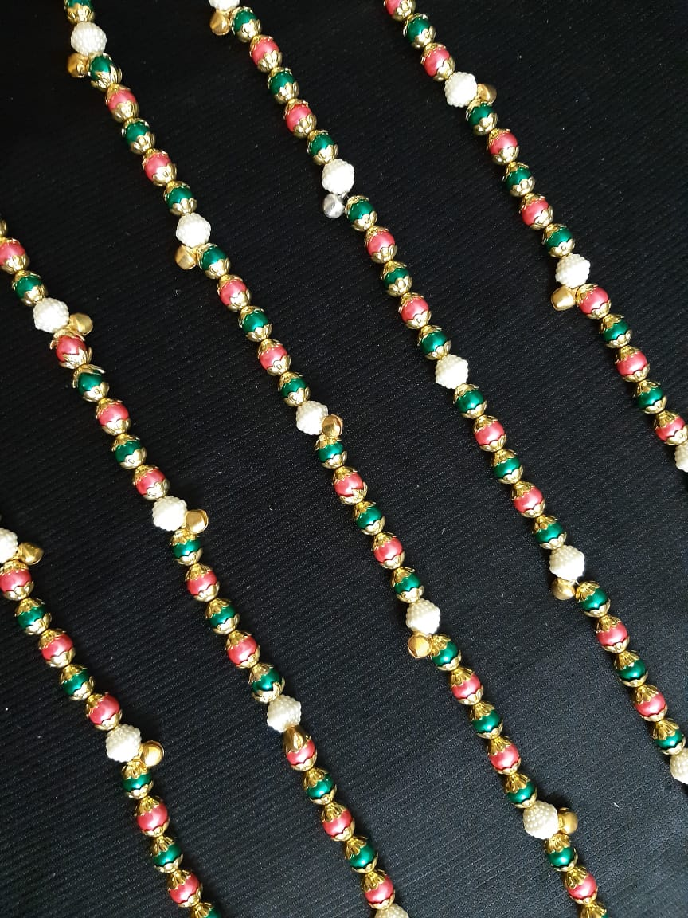

This is our new range of beaded handcrafted curtains. Our contemporary colourful curtains are a perfect decor that creates an illusion of faith of eye's beauty.

Purchase now at just Rs.2,499/-.

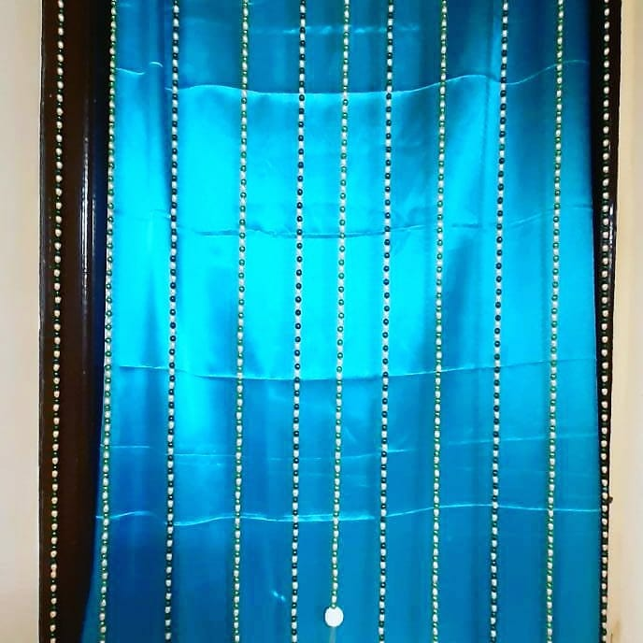

Add beauty to your homes with these beautiful looking pearl curtains.

Buy now at just Rs.1,499/-.

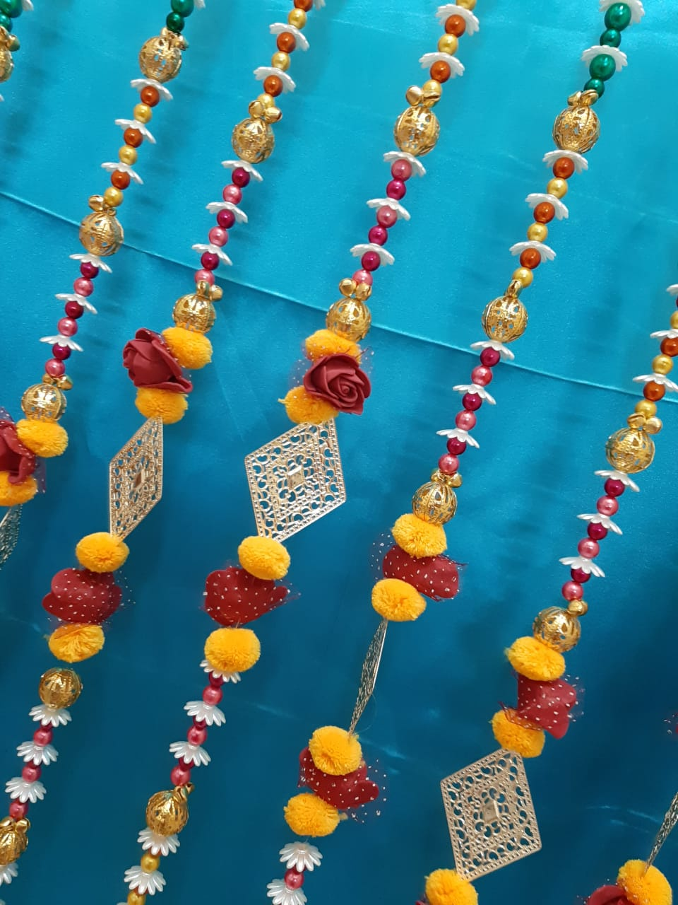

For all you decor lovers, here at Golden Leaf Handicrafts, we have brought to you our most pretty, elegant looking curtains. Get these home and give your doors a beautiful yet enchanting look. These colourful pearl curtains are specially handcrafted.

Get yours now just Rs.2,499/-.

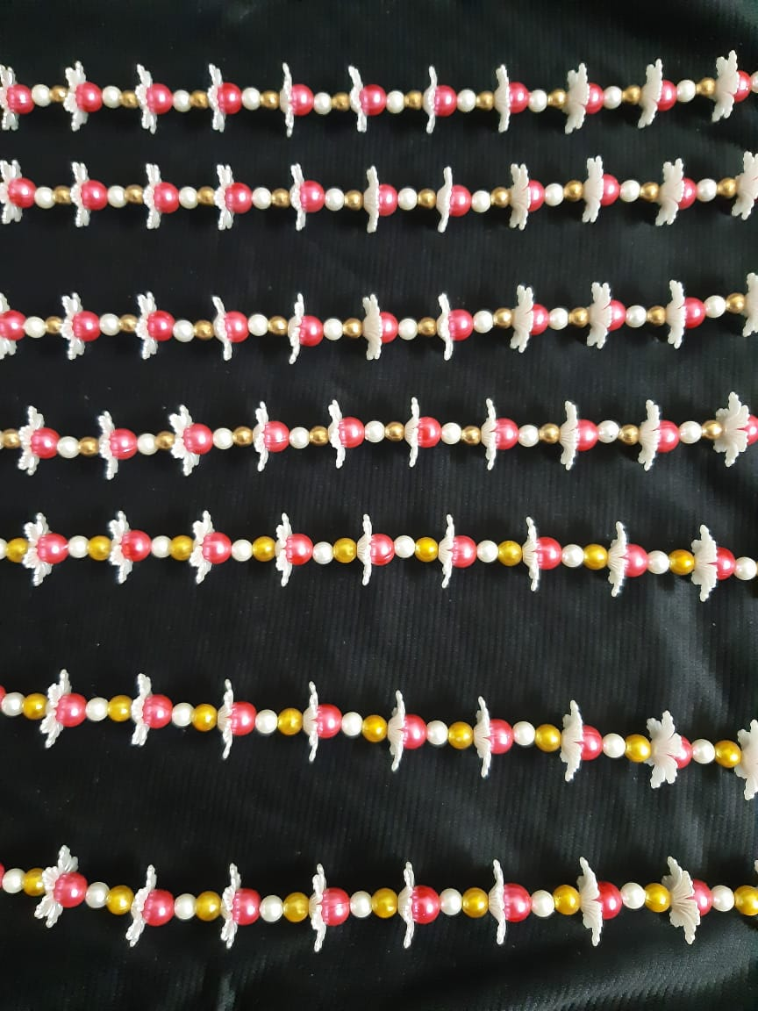

This white petal curtain surrounded by white, golden and pink beads will not only please your eyes but also bring prosperity in your homes.

Purchase them at Rs.1,499/-.

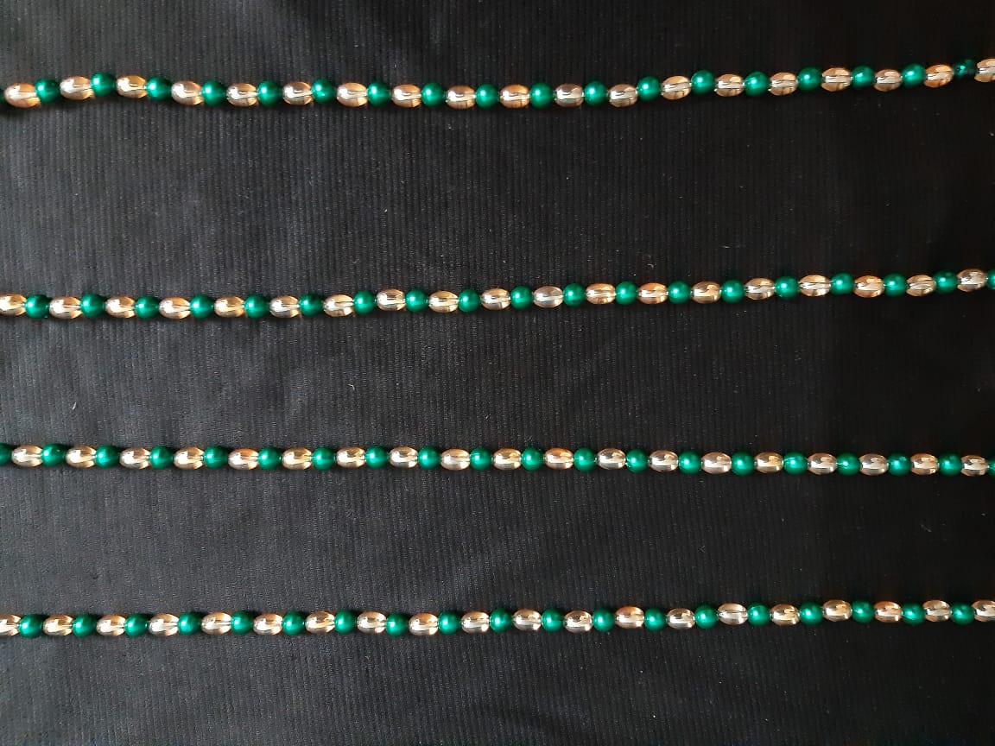

Add beauty to your homes with these beautiful looking crystal+ bead curtains.

Buy now just at Rs.2,000/-.

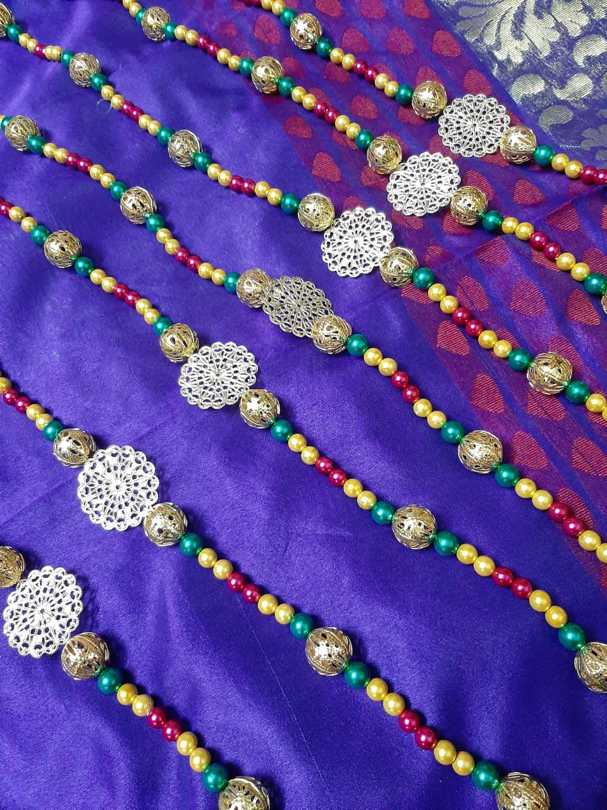

Colourful things always attracts one's eye. If these colours are gathered in one place, it will definitely look pretty. So, we have made this work easy for you. You will surely like our multi-coloured handcrafted curtains.

Shop them now just at Rs.1,999/-.

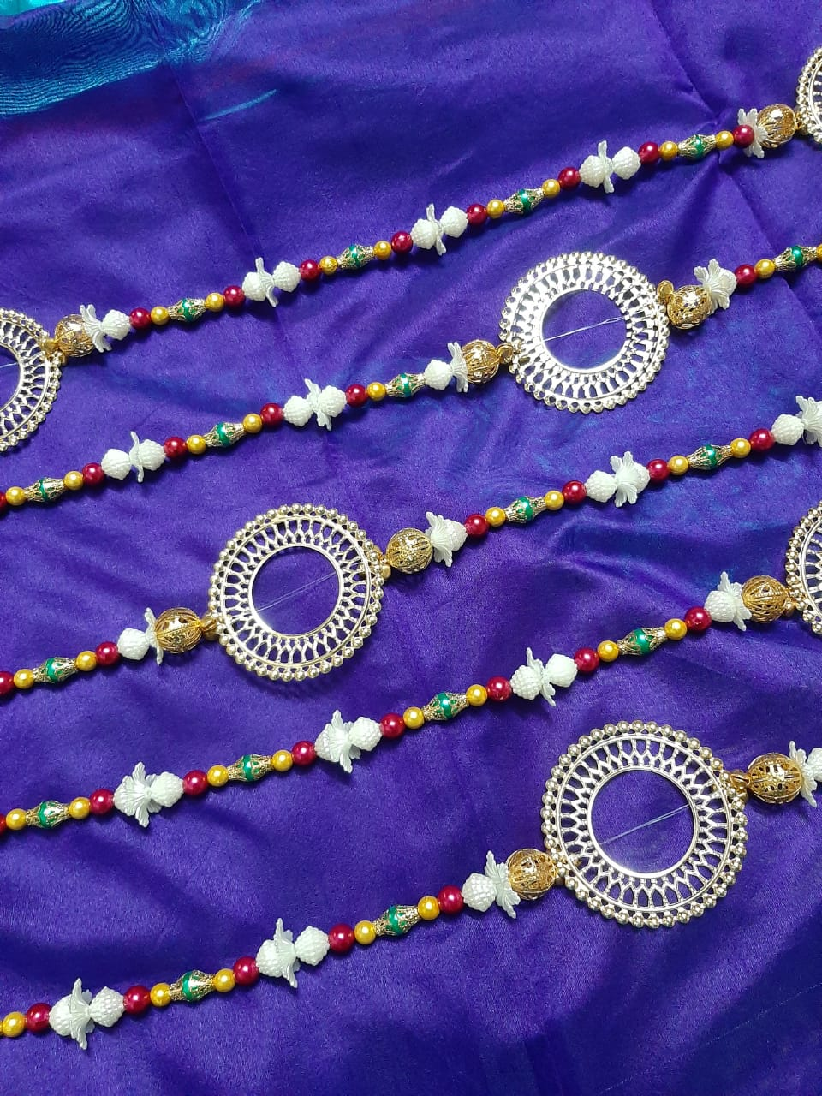

A perfect curtain for all your festive needs.This season, bring home a festive look all throughout the year, with this specially handcrafted curtains, made out of stunning golden decorative ring and lots of beautiful pearls. It will give a rich look to your doors and windows.

Shop now just at Rs.1,999/-.